Food safety program
template records
for class 2 retail and food service businesses,
no. 1, version 3
If you would like to receive this publication in an accessible format please phone
1300 364 352 using the National Relay Service 13 36 77 if required, or email: foodsafety@health.vic.gov.au
This document is available as a PDF on the internet at: www.health.vic.gov.au/foodsafety
© Copyright, State of Victoria, Department of Health 2014
This publication is copyright, no part may be reproduced by any process
except in accordance with the provisions of the Copyright Act 1968.
Unless indicated otherwise, this work is made available under the terms of the Creative Commons Attribution 3.0 Australia licence. To view a copy of this licence, visit creativecommons.org/licenses/by/3.0/au
It is a condition of this Creative Commons Attribution 3.0 Licence that you must give credit to the original author who is the State of Victoria.
Authorised and published by the Victorian Government, 1 Treasury Place, Melbourne.
Except where otherwise indicated, the images in this publication show models and illustrative settings only, and do not necessarily depict actual services, facilities or recipients of services.
ISBN 978-0-9924829-0-9 (Print)
ISBN 978-0-9924829-1-6 (pdf)
(1405008) June 2014

Contents
Introduction 1
Purpose 1
What records will I need? 1
Records 3
Record 1: My food suppliers 3
Record 2: My temperature checks of food in cold or hot storage 3
Record 3: My cooking temperature checks 3
Record 4: How I use the 2 hour/4 hour rule for high-risk food 3
Record 5: My probe thermometer accuracy checks 3

Introduction

Purpose
The purpose of this resource is to assist food business owners to keep the records that will become part
of their food safety programs. Keeping food safety records will help to monitor food safety and hygiene in
your business.
This resource must be read and used in conjunction with the Food safety program template for class 2 retail and food service businesses, no.1, version 3.
If you are unclear about your food safety program or your records:
- speak with your council environmental health officer
- call the dedicated Food Safety Help Line: 1300 364 352
- visit <www.health.vic.gov.au/foodsafety>.
If a food safety problem occurs, records are the best way to demonstrate that you did everything that you should have done to keep food safe.

What records will I need?
The records in this resource are designed to help you monitor the food safety practices that apply to
your business.
You should identify the food safety practices that apply to your business using the companion booklet, Food safety program template for class 2 retail and food service businesses, no.1, version 3 (pages 10 and 11). Each section of this food safety program and the supplement documents indicates the records that you must keep.
- Find the records you will use for your business.
- Look at the examples.
- Check each record to see if it fits the way your business operates.
- If you think a record fits the way your business operates as it is, use a copy of the blank form and add it to your food safety program. Records can be printed from <http://health.vic.gov.au/foodsafety>.
- If the record sheets in this publication do not suit your business, you can design your own. This might include setting out the information differently. If you use an alternative, make sure that:
- you collect the same information as the example record(s) you are replacing
- your written records are in English
- if using remote IT systems to monitor cold storage, refer to the Guide to remote monitoring
of temperatures in food storage units Version 1 at <www.health.vic.gov.au/foodsafety/bus/alternative.htm> or discuss this with your council environmental health officer.
- If you use a record you have designed yourself, add a blank copy to your food safety program. It is recommended that you check with your council environmental health officer to make sure it complies with your food safety program.
- Tick the records you will use in your business in the table on page 2.

My records summary
Requirements | Record-keeping forms | Record number | I will use this record | I have my own record
Select each of these records that apply to your business | My food suppliers  This is a list of all the suppliers you buy or receive food from | Record 1
Select each of these records that apply to your business | My temperature checks at least once a day of a high-risk food in cold or hot storage that is:  - kept in each freezer, refrigerator and cool room and  - held in each hot storage unit  (such as bain maries). | Record 2
Select each of these records that apply to your business | My cooking temperature checks  This records the results of a check each month of whether the cooking temperature of one menu item of food reaches 75°C  or above | Record 3
Select each of these records that apply to your business | How I use the 2 hour/4 hour rule for  high-risk food  This records your system for using the 2 hour/4 hour rule for high-risk food which is on display or available for customers to  serve themselves that is not kept under  5°C or above 60°C | Record 4
Select each of these records that apply to your business | My probe thermometer accuracy checks  This records whether your thermometer is calibrated correctly so that it is showing you the correct temperature of the food | Record 5
To use the records, make sure that all staff members understand:
- what to record
- when to record it
- who will record it
- who will check that records are complete
- who will help if something goes wrong and if equipment is not working
- where records should be stored
- how long records should be stored for.
You may have to show these completed records to your council environmental health officer, so you must keep them on the premises.
Review completed records to identify any problems with food practices or staff knowledge. You must retain the completed records for at least two years.

Records

Record 1: My food suppliers

Record 2: My temperature checks of food in cold or hot storage

Record 3: My cooking temperature checks

Record 4: How I use the 2 hour/4 hour rule for high-risk food

Record 5: My probe thermometer accuracy checks

Record 1: My food suppliers (example)
You can keep this information in any way you like as long as your council environmental health officer can see it on request and your staff can access it in
your absence. Use this sheet if you do not already have this information in existing records.
Keep it in your preferred place, such as in your food safety program, a folder, by the phone, or on your office computer.

This information must include current suppliers and also all your suppliers for the previous two years.
Trading name | Business address | Contact phone number
J. Smith Smallgoods | 999 Street St Suburb, Victoria | 9999 2000
IZ Grocery Street St (these are also your food suppliers whether the food is delivered or picked up) | 333 Street St Suburb, Victoria | 9999 3000

Record 1: My food suppliers
You can keep this information in any way you like as long as your council environmental health officer can see it on request and your staff can access it in
your absence. Use this sheet if you do not already have this information in existing records.
Keep it in your preferred place, such as in your food safety program, a folder, by the phone, or on your office computer.
This information must include current suppliers and also all your suppliers for the previous two years.
Trading name | Business address | Contact phone number
Note: Do not write on this master form. Make several photocopies to put in your records folder.

Record 2: My temperature checks of food in cold or hot storage (example)
High-risk food must be kept at safe temperatures. Cold food must be kept at 5°C or less, frozen food at -15°C or colder, and hot food at 60°C or hotter.
High-risk food will become unsafe if it is kept in the temperature danger zone between 5°C and 60°C.
At least once every day that your business operates at a premises, vehicle, stall or off-site location, for each site check and record the temperature of at least one high-risk food in each unit in which you keep food frozen, cold or hold it hot.
Record the result. If the temperature is wrong check other items and take corrective action. Try to vary the items checked over the course of the week.
You can choose the way you keep this information, such as in the record below, in your daily business diary, or somewhere that the information can be retrieved quickly, if requested. Make sure you record the date, unit and food temperature, and any corrective action taken.
If you are keeping the record for more than one location, make sure it is clear which premises, van, stall or off-site location it relates to.
If you are using a remote monitoring system, you can use the records in that system.
Premises: | City Restaurant
Unit name: | Cool room
Week starting: 13/07/2014 | Temperature of food (1 x item) | Corrective action taken (if temperature wrong)
Sunday | 3˚C
Monday | 4˚C
Tuesday | 5˚C
Wednesday | 4˚C
Thursday | 6˚C | Temperature adjusted
Friday | 4˚C
Saturday | 5˚C

Record 2: My temperature checks of food in cold or hot storage (example) – (continued)
Premises: | Food van (Rego: TVL 341)
Unit name: | Food van fridge
Week starting: 13/07/2014 | Temperature of food (1 x item) | Corrective action taken (if temperature wrong)
Sunday | 10˚C | Fixed by technician
Monday | 4˚C
Tuesday | 5˚C
Wednesday | 4˚C
Thursday | 6˚C | Temperature adjusted
Friday | 4˚C
Saturday | 5˚C

Record 2: My temperature checks of food in cold or hot storage (example) – (continued)
Premises: | Stall or marquee
Unit name: | Pie warmer
Week starting: 13/07/2014 | Temperature of food (1 x item) | Corrective action taken (if temperature wrong)
Sunday | N/A
Monday | N/A
Tuesday | N/A
Wednesday | N/A
Thursday | 52ºC | Pies microwaved and returned to the warmer. Core temperature is now 76ºC. Updated practice communicated to all staff.
Friday | 64ºC
Saturday | 65ºC

Record 2: My temperature checks of food in cold or hot storage (example) – (continued)
Premises: | Catering set up for parties
Unit name: | Soup turine
Week starting: 13/07/2014 | Temperature of food (1 x item) | Corrective action taken (if temperature wrong)
Sunday | N/A
Monday | N/A
Tuesday | N/A
Wednesday | N/A
Thursday | 82ºC
Friday | 78ºC
Saturday | 66ºC

Record 2: My temperature checks of food in cold or hot storage
High-risk food must be kept at safe temperatures. Cold food must be kept at 5°C or less, frozen food at -15°C or colder, and hot food at 60°C or hotter.
High-risk food will become unsafe if it is kept in the temperature danger zone between 5°C and 60°C.
At least once every day that your business operates at a premises, vehicle, stall or off-site location, for each site check and record the temperature of at least one high-risk food in each unit in which you keep food frozen, cold or hold it hot.
Record the result. If the temperature is wrong check other items and take corrective action. Try to vary the items checked over the course of the week.
You can choose the way you keep this information, such as in the record below, in your daily business diary, or somewhere that the information can be retrieved quickly, if requested. Make sure you record the date, unit and food temperature, and any corrective action taken.
If you are keeping the record for more than one location, make sure it is clear which premises, van, stall or off-site location it relates to.
If you are using a remote monitoring system, you can use the records in that system.
Premises:
Unit name:
Week starting: | Temperature of food (1 x item) | Corrective action taken (if temperature wrong)
Sunday
Monday
Tuesday
Wednesday
Thursday
Friday
Saturday
Note: Do not write on this master form. Make several photocopies to put in your records folder.

Record 2: My temperature checks of food in cold or hot storage – (continued)
Premises:
Unit name:
Week starting: | Temperature of food (1 x item) | Corrective action taken (if temperature wrong)
Sunday
Monday
Tuesday
Wednesday
Thursday
Friday
Saturday
Note: Do not write on this master form. Make several photocopies to put in your records folder.

Record 2: My temperature checks of food in cold or hot storage – (continued)
Premises:
Unit name:
Week starting: | Temperature of food (1 x item) | Corrective action taken (if temperature wrong)
Sunday
Monday
Tuesday
Wednesday
Thursday
Friday
Saturday
Note: Do not write on this master form. Make several photocopies to put in your records folder.

Record 3: My cooking temperature checks (example)
High risk food must be cooked to at least 75ºC to be safe.
At least once a month that your business operates at a premises, vehicle, stall or off-site location, for each site check and record the results of whether the cooking temperature of one menu item of food reaches 75ºC or above.
Make sure you record the date, food item and temperature and, if needed, any action taken to ensure food reaches more than 75ºC.
Try to vary the items checked over the course of the year.
You can choose the way you keep this information, such as in the record below, in your daily business diary, or somewhere that the information can be retrieved quickly, if requested. Make sure you record all the required information.
Whole cuts of fish or steak can be cooked to preference and do not need to reach a core temperature of 75ºC.
If you are keeping the record for more than one location, make sure it is clear which premises, van, stall or off site location it relates to.
If all of the food you cook is fried, you do not need to conduct this check or complete the record.
Premises: | Restaurant
Date | Menu item to verify cooking temperature | Internal cooking temperature reached is greater than 75ºC (✓ or ✗ ) | Any changes to cooking practice to reach greater  than 75ºC
21/10/2014 | Beef rendang curry | ✗ | If 10L pot used then cook for 2 hours, recipe card updated to show this.
21/11/2014 | Chicken casserole | ✓ | N/A

Record 3: My cooking temperature checks
High risk food must be cooked to at least 75ºC to be safe.
At least once a month that your business operates at a premises, vehicle, stall or off-site location, for each site check and record the results of whether the cooking temperature of one menu item of food reaches 75ºC or above.
Make sure you record the date, food item and temperature and, if needed, any action taken to ensure food reaches more than 75ºC.
Try to vary the items checked over the course of the year.
You can choose the way you keep this information, such as in the record below, in your daily business diary, or somewhere that the information can be retrieved quickly, if requested. Make sure you record all the required information.
If you are keeping the record for more than one location, make sure it is clear which premises, van, stall or off site location it relates to.
Whole cuts of fish or steak can be cooked to preference and do not need to reach a core temperature of 75ºC.
If all of the food you cook is fried, you do not need to conduct this check or complete the record.
Premises:
Date | Menu item to verify  cooking temperature | Internal cooking temperature reached is greater than 75ºC (✓ or ✗ ) | Any changes to cooking practice  to reach greater than 75ºC
Note: Do not write on this master form. Make several photocopies to put in your records folder.

Record 4: How I use the 2 hour/4 hour rule for high-risk food
Complete this record if your business keeps high-risk food on display in the temperature danger zone of 5°C to 60°C.
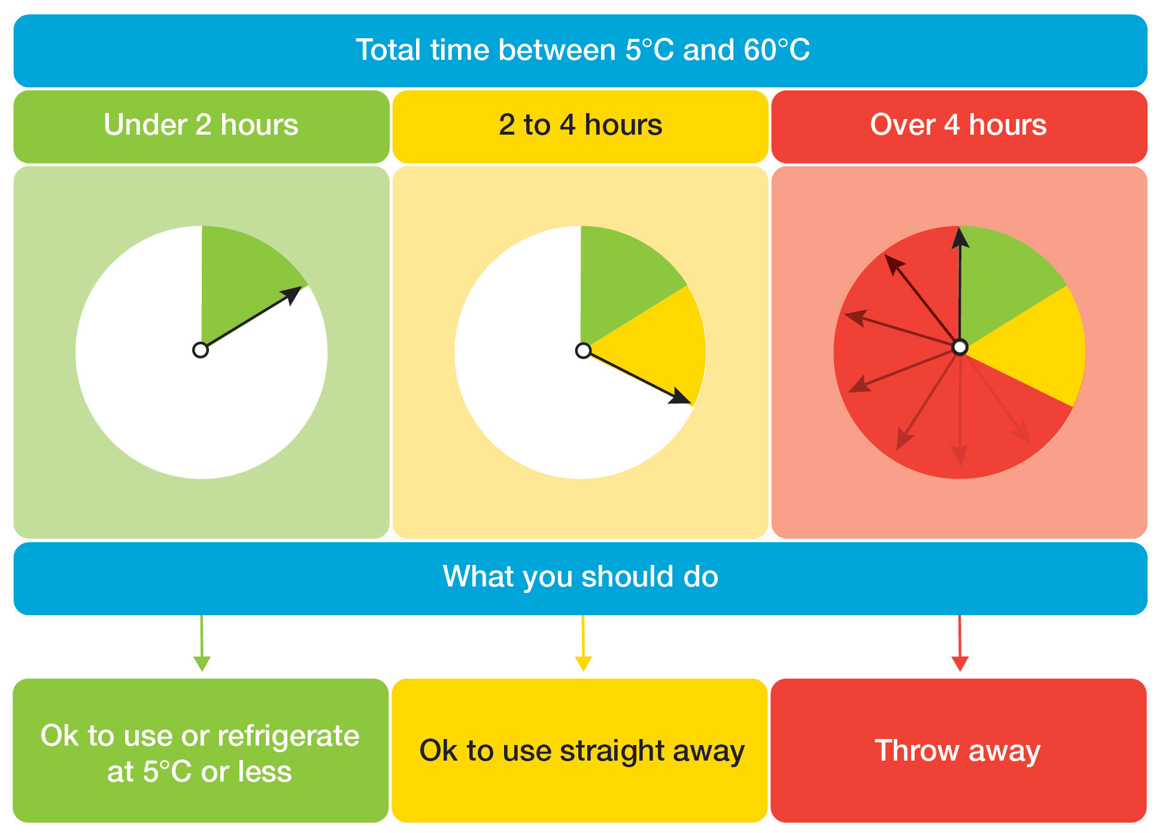
You will need to comply with the 2 hour/4 hour rule. It uses time and temperature control to keep
food safe.

The total time includes all the time the food has been at room temperature, for example during delivery, display, preparation and transportation.
If you keep high-risk food on display in the temperature danger zone of 5°C to 60°C write down your usual practice for using the 2 hour/4 hour rule, and make sure you and your staff understand it. See the examples below.
If you are keeping this record for more than one location, make sure it is clear which premises, van, stall or off-site location it relates to.

Example practice 1:
Premises: (Example) Bean and Gone Café
- Sandwiches are prepared daily between 10.30 and 11.30am.
- They are put on display until 2.30pm – total time out of refrigeration is four hours.
- At 2.30pm all left over sandwiches are thrown out.

Example practice 2:
Premises: (Example) Big Belly Buffet Restaurant

Monday to Saturday
- Freshly cooked food is transferred to the bain-marie daily at 11.50am for lunch service – food is
held at 50°C.
- All food is brought back to the kitchen at 2.30pm.
- As the food has been in the temperature danger zone of 5°C to 60°C for longer than two hours, it
is either used immediately (some staff eat it for lunch before the four-hour mark is reached) or it is thrown out.

Sundays
- Freshly cooked food is transferred to the bain-marie daily at 11.50am for lunch service – food is held at 50°C.
- Leftover food is brought back into the kitchen after lunch service at 1.30pm where it cooled rapidly in shallow containers in the refrigerator for use the next day.
Note: In example 2, the 1 hour and 40 minutes that the food is held in the bain-marie on Sunday is part of
the total amount of time the food can be held in the temperature danger zone the next day. That is, on Monday, after reheating to over 75°C, the food can be displayed for 2 hours and 20 minutes before being thrown out. The total time in which the food is kept in the temperature danger zone is 4 hours.

Your practice: Time and temperature control (2 hour/4 hour rule)
Write down your usual practice here for using the 2 hour/4 hour rule. Update it if your practice changes. (Add new pages if you need to.)
___________________________________________________________________________________
___________________________________________________________________________________
___________________________________________________________________________________
___________________________________________________________________________________
___________________________________________________________________________________
___________________________________________________________________________________
___________________________________________________________________________________
___________________________________________________________________________________
___________________________________________________________________________________
___________________________________________________________________________________
___________________________________________________________________________________
___________________________________________________________________________________
___________________________________________________________________________________
You must be able to demonstrate how you manage food safety in your business to the council environmental health officer.

Record 5: My probe thermometer accuracy
checks (example)
Many thermometers are calibrated accurately when you buy them. Check the packet for details. This accuracy can be lost if it gets bumped, dropped or is used over a long time. You need to make sure your thermometer is showing you the right temperature of food. You may want to check this more often, but you must check each thermometer at least once within each 12-month period and record the result.
The thermometer must be an analogue or digital probe-type thermometer (pictured below) so you can measure the internal temperature of food accurate to +/-1°C.
- If you measure the temperature of hot food, complete the boiling check.
- If you measure the temperature of cold food, complete the ice water check.
- If you use the thermometer for both hot and cold food, complete both checks.

Date | Thermometer ID  If you have more than one, name it, e.g. T1, T2, T3, and label it | Temperature °C ice water  Temperature that the thermometer displays | Temperature °C boiling water  Temperature that the thermometer displays | Corrective action  (if temperature wrong)  Record the action taken  to fix problem
01/10/2013 | T1 | 0˚C | 97˚C | New thermometer purchased.
01/10/2013 | T2 (used in  food van) | 0˚C | 99˚C | N/A
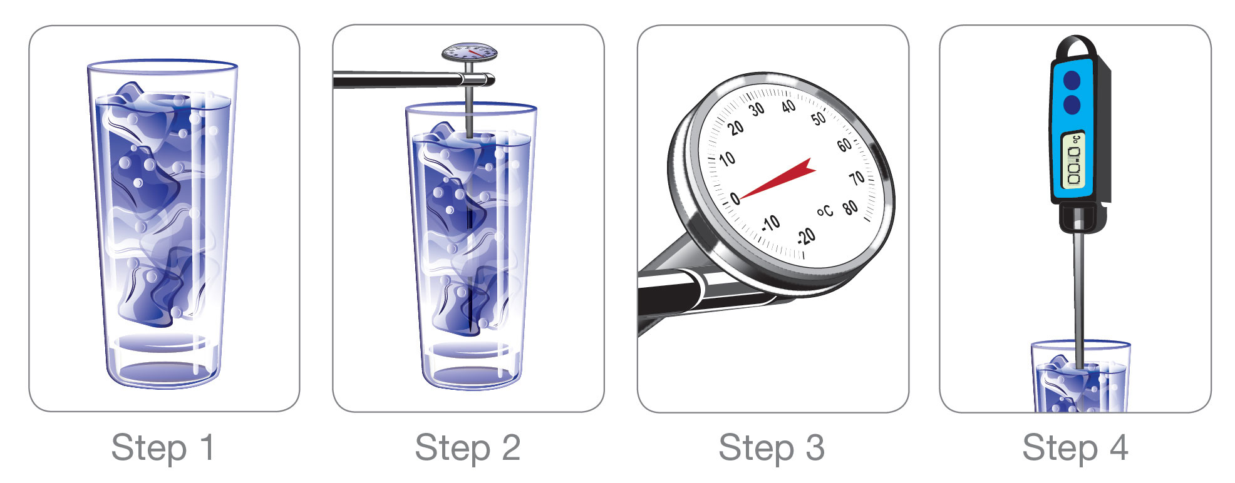

Ice water check
- Mix ice and water in a container. Let it sit for a few minutes. This will chill the water to 0°C.
- Insert the thermometer for at least 10 seconds until the reading is stable.
- An accurate thermometer will show a temperature between -1°C and +1°C.
- If it shows a temperature greater or less than -1°C and + 1°C, the thermometer is inaccurate
and needs to be replaced immediately.
Boiling water check
- Boil some water.
- Carefully insert the thermometer for at least 10 seconds until the reading is stable.
- An accurate thermometer will show a temperature between 99°C and 101°C.
- If it shows a temperature greater or less than 99°C and 101°C, the thermometer is inaccurate and needs to be replaced immediately.

Record 5: My prob thermometer accuracy checks (example) continued

Record 5: My probe thermometer
accuracy checks
Many thermometers are calibrated accurately when you buy them. Check the packet for details. This accuracy can be lost if it gets bumped, dropped or is used over a long time. You need to make sure your thermometer is showing you the right temperature of food. You may want to check this more often, but you must check each thermometer at least once within each 12-month period and record the result.
The thermometer must be an analogue or digital probe-type thermometer (pictured below) so you can measure the internal temperature of food accurate to +/-1°C.
- If you measure the temperature of hot food, complete the boiling check.
- If you measure the temperature of cold food, complete the ice water check.
- If you use the thermometer for both hot and cold food, complete both checks.

Ice water check
- Mix ice and water in a container. Let it sit for a few minutes. This will chill the water to 0°C.
- Insert the thermometer for at least 10 seconds until the reading is stable.
- An accurate thermometer will show a temperature between -1°C and +1°C.
- If it shows a temperature greater or less than -1°C and + 1°C, the thermometer is inaccurate and needs to be replaced immediately.

Boiling water check
- Boil some water.
- Carefully insert the thermometer for at least 10 seconds until the reading is stable.
- An accurate thermometer will show a temperature between 99°C and 101°C.
- If it shows a temperature greater or less than 99°C and 101°C, the thermometer is inaccurate and needs to be replaced immediately.

Record 5: My probe thermometer accuracy checks – (continued)
Date | Thermometer ID  If you have more than one, name it, e.g. T1, T2, T3, and label it | Temperature °C ice water  Temperature that the thermometer displays | Temperature °C boiling water  Temperature that the thermometer displays | Corrective action  (if temperature wrong)  Record the action taken  to fix problem

Note: Do not write on this master form. Make several photocopies to put in your records folder.

